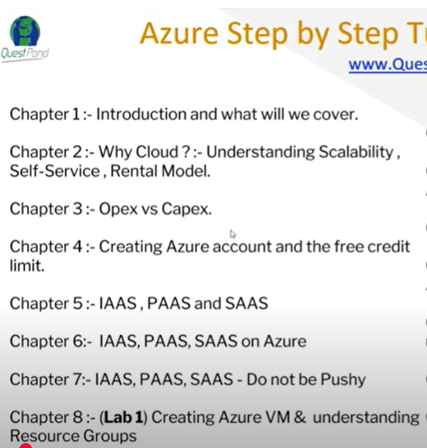

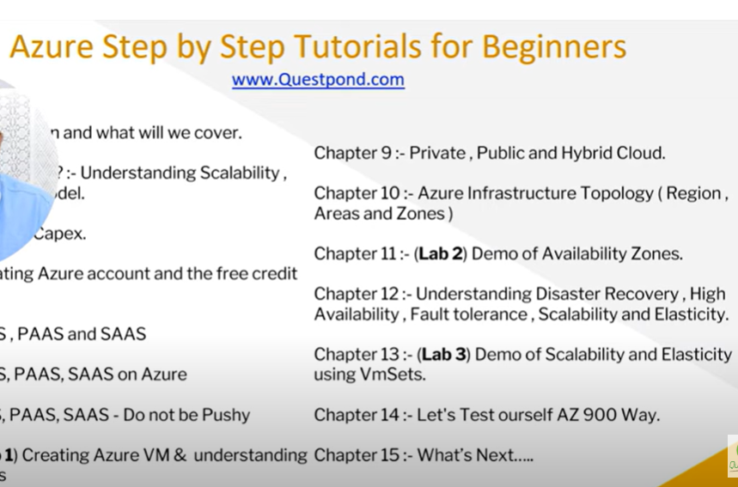



**Why Cloud?**

The cloud has 3S 🡪 Scalability, Self Service, and Spend as you go(or Pay as you go or Subscription as you go)

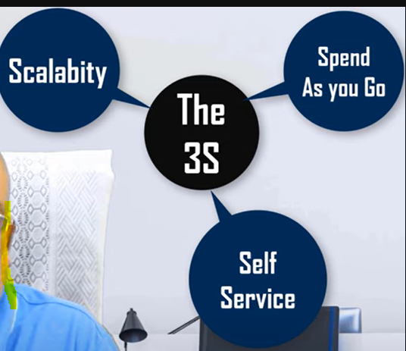 

While creating the VM, I can set the scalability to increase the VM

Once my CPU threshold goes above 80%, increase one VM automatically.

Automatic Scalability

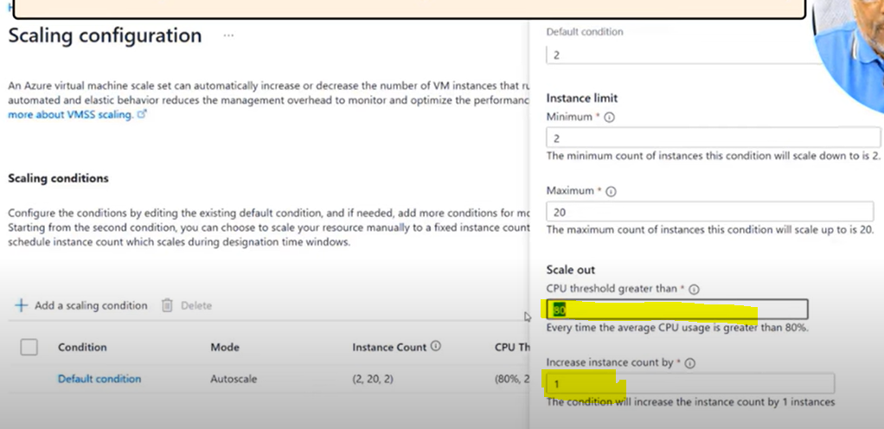



In other services, I should call them for my new virtual machine or to increase my memory size. But in the cloud(Azure), we can update everything on our own without any interaction with the customer care or the organization.



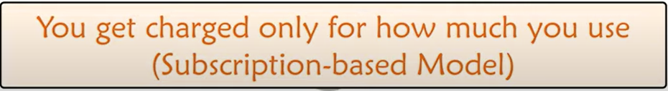

They only charge me for what I used.



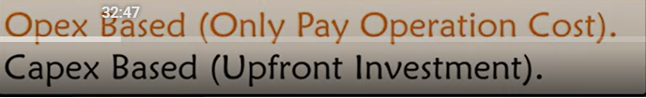



**Opex vs Capex Based:**

Capex 🡪 Capital Expenditure

Opex 🡪 Operational Expenditure

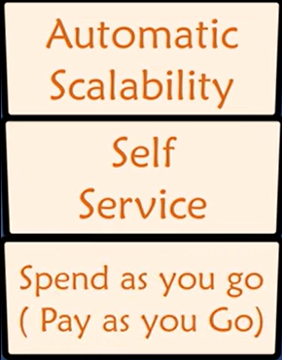 **There are three reasons we go for the Cloud.**

**Comparison between CapEx and OpEx:**

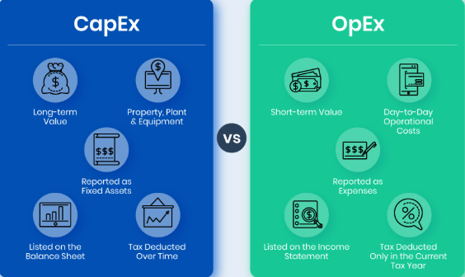 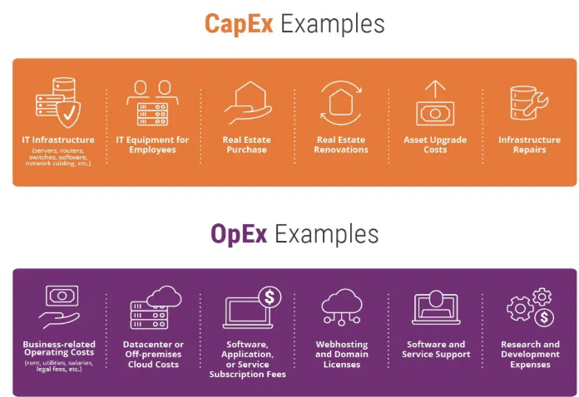

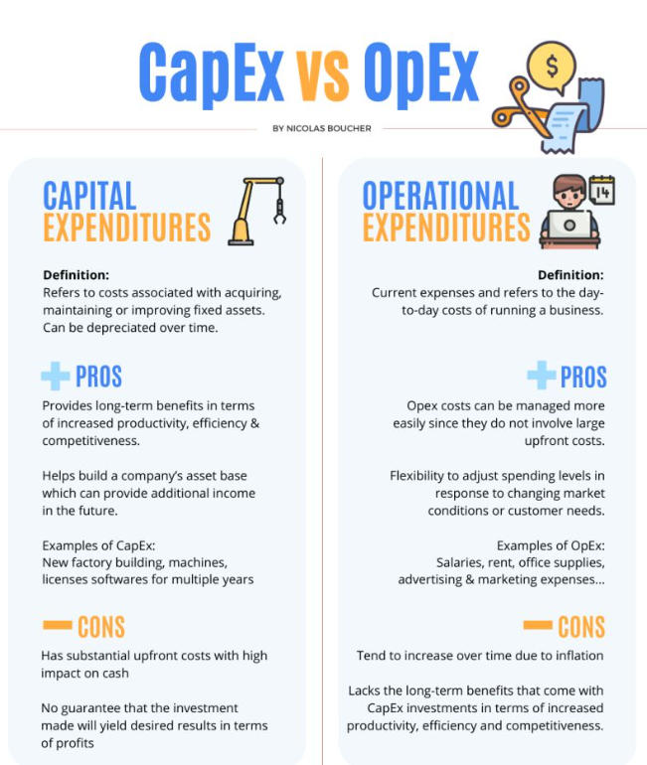



**Creating an Azure Account and Free Credit Limit:**

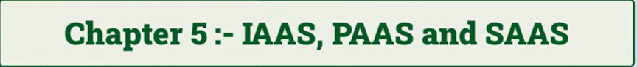

**Pay-as-you-go services are below:**

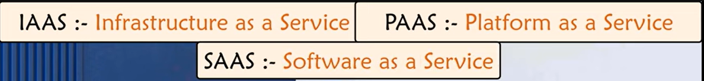

Here, these services are not we are owning it, instead we pay and use them.

**For example**, Hotel service 🡪 go to the hotel and order the food, eat it, and then pay for it.

**IAAS 🡪 Infrastructure as a Service**

**PAAS 🡪 Platform as a Service**

**SAAS 🡪 Software as a Service**

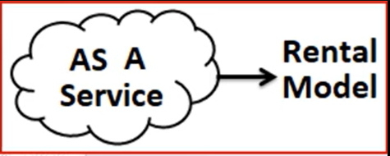 Service means Rental Model.

**IAAS 🡪 Infrastructure as a Service**

* Infrastructure as a Service is like renting virtual hardware over the internet.
* Instead of buying and maintaining physical servers,
* You get access to virtual machines, storage, and networking resources.
* that you can scale as needed.
* It's flexible, cost-effective, and lets you focus on your applications rather than the underlying hardware.
* For example, you need a powerful machine to run your software or store data, but you don't want to buy or manage the physical hardware.
* With **IaaS**, Azure provides virtual machines and resources that you can use remotely.
* It's like having a computer in the cloud that you can customize and scale as your needs change.
*  

**PAAS 🡪 Platform as a Service**

* Platform as a Service (PaaS) in Azure provides a ready-to-use environment for developing, testing, and deploying applications without managing the underlying infrastructure.
* It's like having a fully-equipped workshop where you just bring your code and start building, with everything else taken care of.
* For example, imagine you want to build an app.
* **Platform as a Service (PaaS)**, Azure gives you the tools and environment you need—like a development framework, database management, and hosting—without worrying about the underlying servers or storage.
* You focus on coding, and Azure handles the rest.
* It's like cooking in a kitchen where all the ingredients and appliances are ready to go.
* 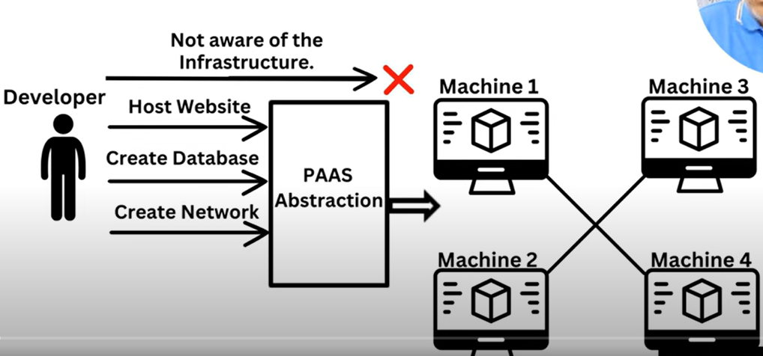

**SAAS 🡪 Software as a Service**

* Software as a Service (SaaS) in Azure is like subscribing to software that's fully managed and hosted by Azure.
* You just use the application via the internet without worrying about installing, maintaining, or updating it.
* It's all handled for you.
* **Software as a Service (SaaS)** is like renting a car.
* With Azure, you just "rent" the software over the internet.
* Everything's ready to use, no need to install or maintain it.
* You just use it when you need it.
* it's like using an app on your phone.
* You just open it and use it,
* no need to set up or worry about how it works behind the scenes.
* 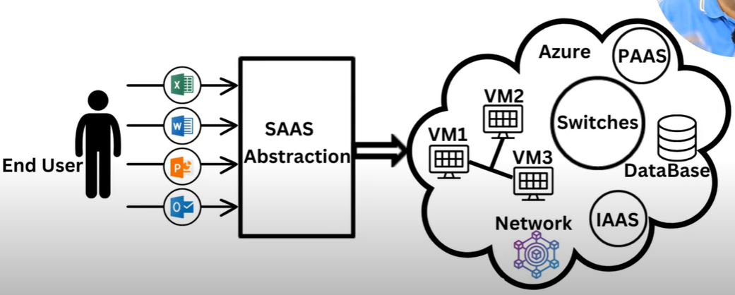

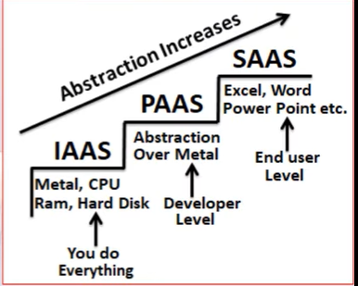 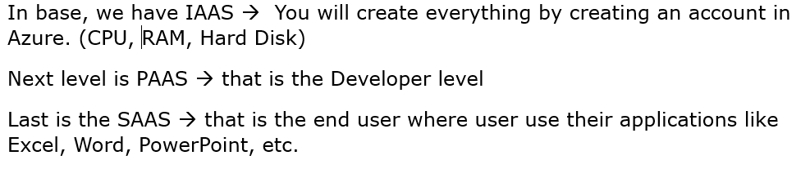



**How are these IAAS, PAAS, and SAAS used in Azure?**

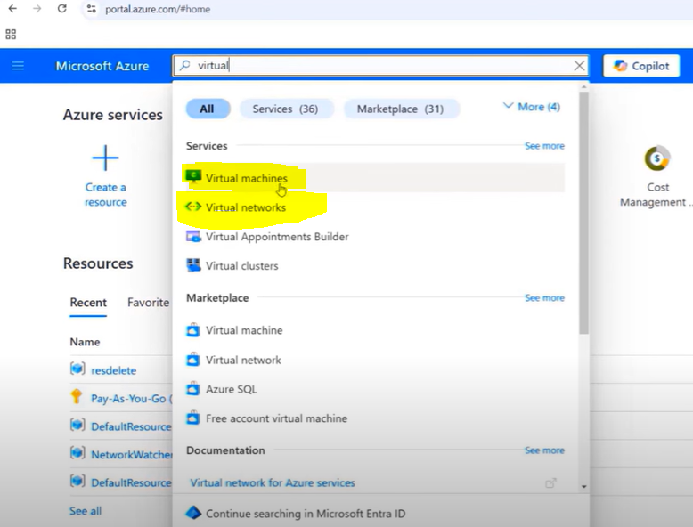 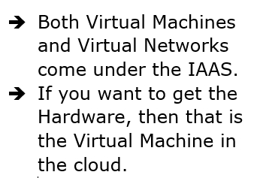

* Virtual Machine 🡪 This is the place where you get access to the RAM, Hard Disk, etc.
* This is called the **Infrastructure as a Service (IAAS)**

Below is the **Platform as a Service (PAAS)**

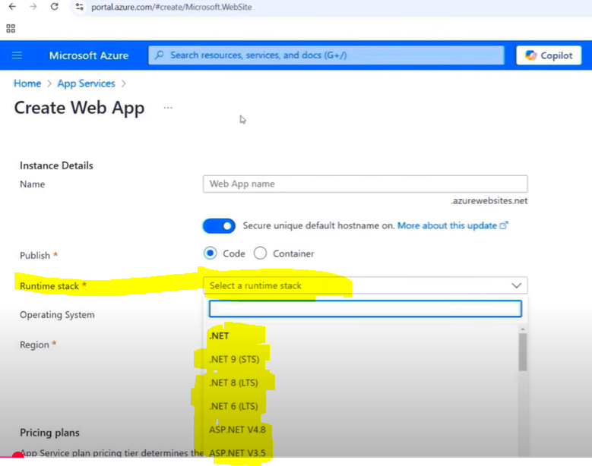 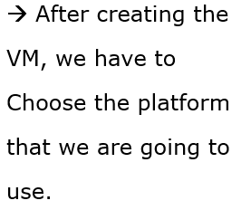

Below is the **SAAS – Software as a Service**

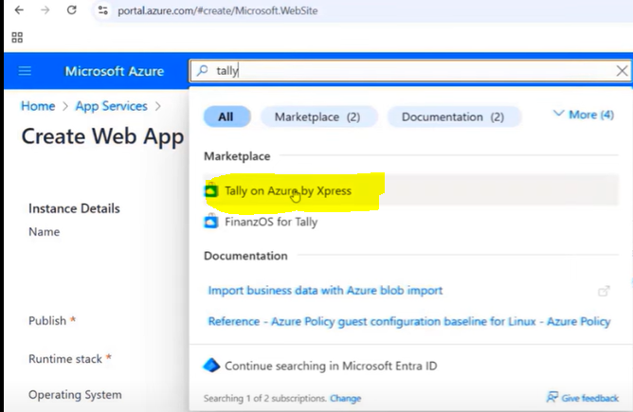



* In essence, "do not be pushy" in the context of IaaS, PaaS, and SaaS means choosing the right tool for the job,
* considering the level of control and responsibility, and avoiding solutions that don't align with the specific needs
* and the technical capabilities of the user or organization.
* 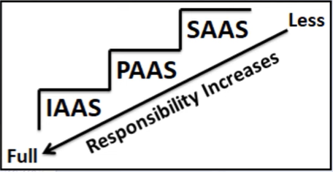

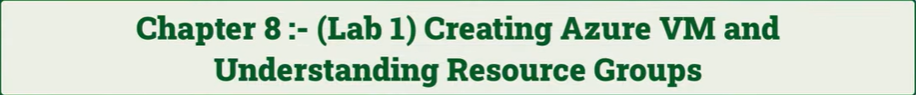

**Creating the Virtual Machine in the Azure Portal:**

The first Resource:

* On creating a VM, it means that the person who creates is more responsible for what they are doing in the IAAS.
* **Subscription** 🡪 Inside one company, there can be multiple subscriptions with different credit cards.
* Like saying that this credit card is for this division, and this credit card is for this division.
* **Resource Group** 🡪 It is the collection of Azure items or Azure entities.
* RDP – Remote Desktop Protocol 🡪

**Azure Portal 🡪 Search bar 🡪 Virtual Machines 🡪 + Create 🡪 Azure virtual machine 🡪**

**Basics Tab** 🡪

(Subscription (free or pay as you go), Resource group, Virtual machine name, Region, Availability options – choose No infrastructure redundancy required, Security type – Trusted launch virtual machines, Image – Ubuntu Server 24.04 LTS – x64 Gen2, VM architecture – x64, size, Administrator account 🡪 Username, Password, Confirm password)

**Disks Tab** 🡪

**Networking Tab** 🡪 Here we will have our public IP address.

**Management Tab** 🡪

**Monitoring Tab** 🡪 Alerts, Diagnostics, Health, etc.

**Advanced Tab** 🡪

**Tags Tab** 🡪

**Review + Create Tab** 🡪

Once the VM created then it will be shown like the below image.

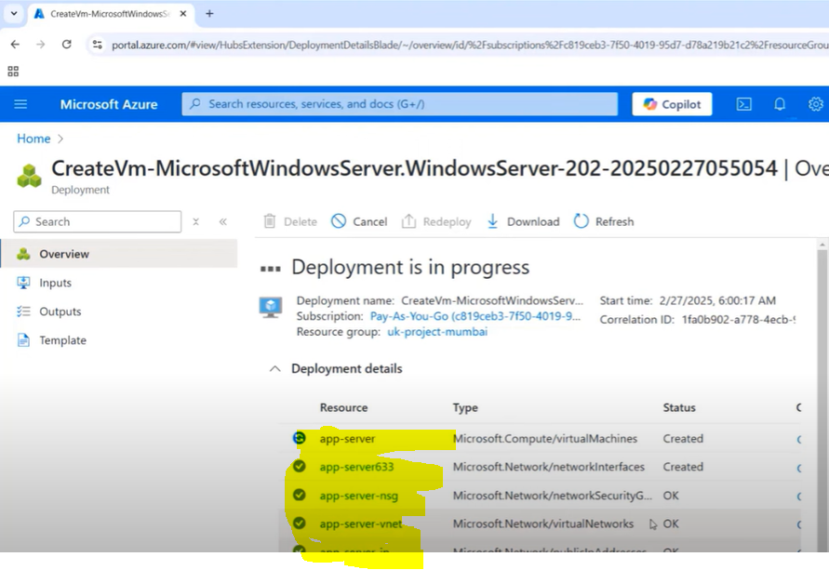 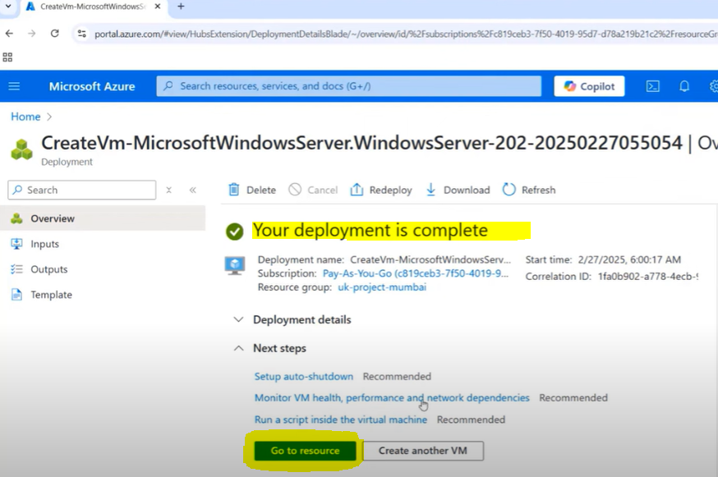

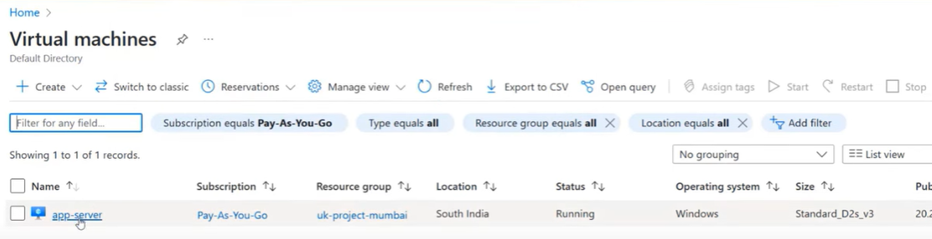

* Once the VM is created, click on it and copy the IP address.

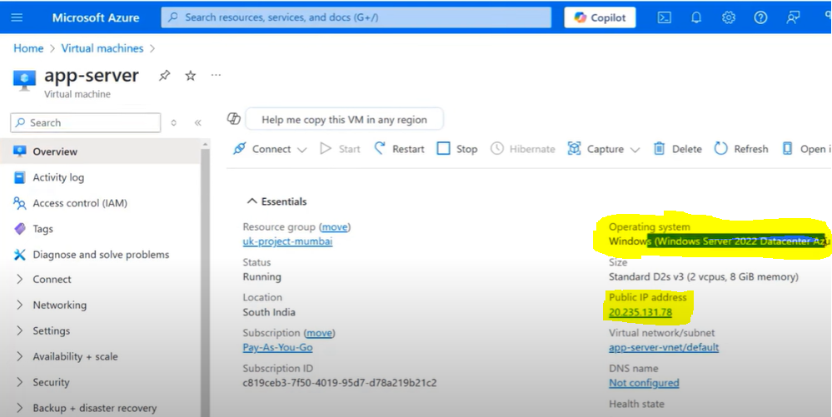

* For windows os 🡪 getting into Windows mstc 🡪 paste the ip address in the computer 🡪 connect

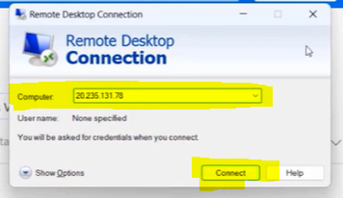

* Using the VM is not only the cloud.
* Creating a VM is just a lift and shift; it is one of the services we use in Azure.
* **After completing every lab, practice deleting all the resource groups to avoid the rental cost to Azure.**



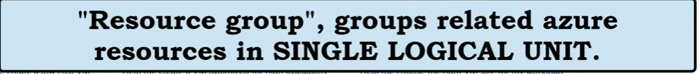



**3 Concepts in Cloud are below**

**Private Cloud, Public Cloud, and Hybrid Cloud:**

**Public Cloud:**

* It's a service where Microsoft offers computing resources like servers and storage over the internet,
* So you can access and use them without owning or managing any physical hardware.
* **For Example**, think of it like renting a computer in the cloud;
* You use it when you need it, but you don't have to own or maintain the actual machine.
* It's like renting a spot in a tech playground, sharing space and resources with others.
* It's cheaper, and you pay for what you use.
* It is more like renting space in a massive shared office building.
* Many organizations share the resources, it's scalable, and you typically pay only for what you use.

**Private Cloud:**

* It is like your own personal computer network.
* It's dedicated to one organization, providing more control and security, usually hosted on-site or in a dedicated off-site center.
* Think of it as your private IT playground—only you can play, customize everything, and keep it secure.

**Hybrid Cloud:**

* It is a Mix of both worlds.
* You keep sensitive stuff in your private playground and use the shared one for everything else.
* It's flexible and efficient.
* It is a blend of both,
* using private cloud for sensitive operations and
* public cloud for more general tasks, offering flexibility and efficiency.
* It's like having both a private workspace and access to shared facilities when needed.

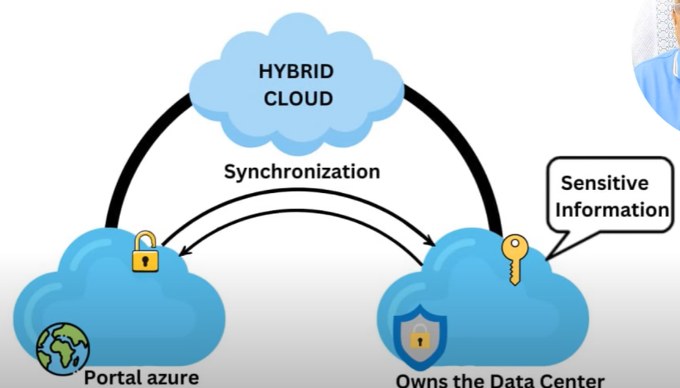

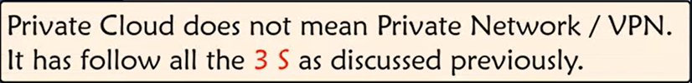

* Portal. Azure 🡪 Public cloud
* Data Center 🡪 Private cloud (having some server or system as a private machine) 🡪 Private cloud doesn’t mean by private network. It is not a VPN (VPN is not a private cloud.)
* Online booking with secure data 🡪 Hybrid cloud (Here, they will synchronize both public and private cloud).



**Azure Infrastructure Topology:**

**Talking about Region, Areas, and Zones:**

How is it organized?

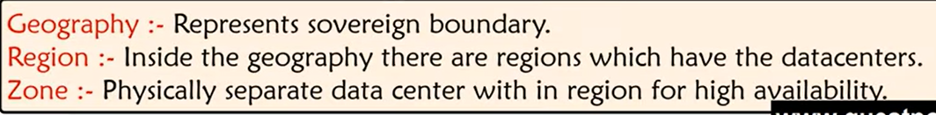

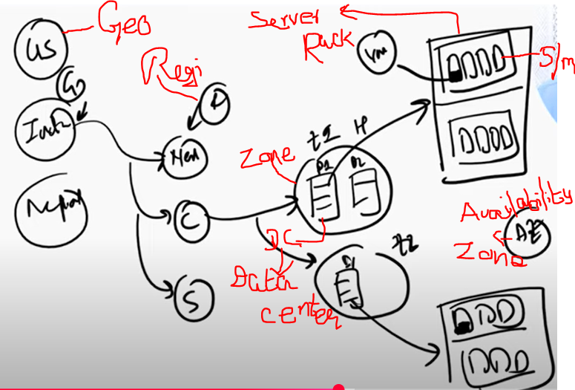

* Geography 🡪 Countries (India, US, Nepal…)
  + Below that Regions 🡪 Within each country (North, South, Central India…)
    - Below that Zones 🡪 (within the regions zone1, zone2…)
      * Below that Data Center 🡪 (in every zone, they will be having many data centers, like datacenter1, datacenter2…)



Availability Zone:

* Azure Availability Zones are like different neighbourhoods in a city.
* They're separate locations within a region, each with independent power, cooling, and networking.
* This setup protects your applications and data from datacenter failures,
* So your services stay up and running even if one zone goes down.
* **Example**: Think of Availability Zones in Azure like having multiple backups in different places.
* If one place has issues, your data and apps still run smoothly from another place.
* It keeps things running even if there's a problem in one area.

**Load Balancing:**

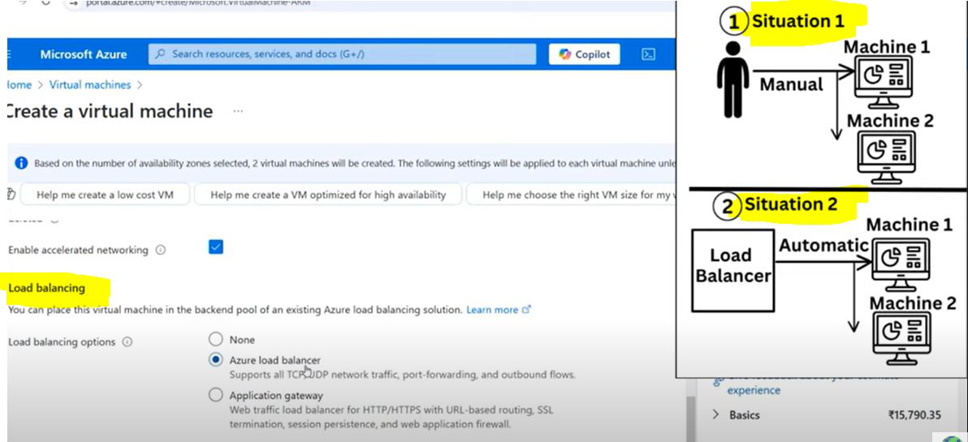

* Load balancing in Azure refers to distributing incoming network traffic across multiple servers or resources to **ensure high availability, scalability, and reliability** of your applications or services.
* Load balancing in Azure is like sharing a workload among several workers so no single one gets overwhelmed.
* It helps prevent any single server from becoming overwhelmed with too much traffic, which could lead to performance issues or downtime.
* Imagine you own a busy restaurant, and instead of one server handling all the tables, you spread customers out across multiple servers to keep everything running smoothly.
* Load balancing helps ensure that applications or services stay fast, reliable, and available by directing traffic to different servers or resources based on need.
* Azure offers tools or types of Load Balancers to do this, like the
* **\*Azure** **Load Balancer\*** 🡪 for basic distribution
  + **🡪** Used for distributing traffic across virtual machines in the same region.,
* **\*Azure** **Application Gateway\*** 🡪 for more advanced tasks (like routing specific kinds of requests),
  + **🡪** A layer 7 load balancer with additional features like web application firewall, SSL termination, and URL-based routing.
* **\*Azure** **Traffic Manager\*** 🡪 for spreading traffic across multiple locations worldwide.
  + **🡪** A DNS(Domain Name System)-based load balancer for distributing traffic across different regions or data centers.
* It's all about keeping things efficient and steady!

Here shows the **Manual Load Balancer** instead of the Automatic Load Balancer:

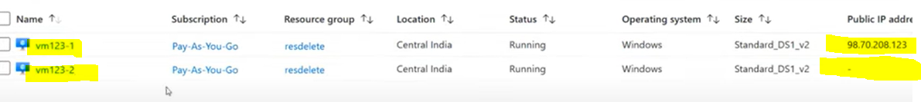

* One VM is running in one zone and the other in another zone.
* 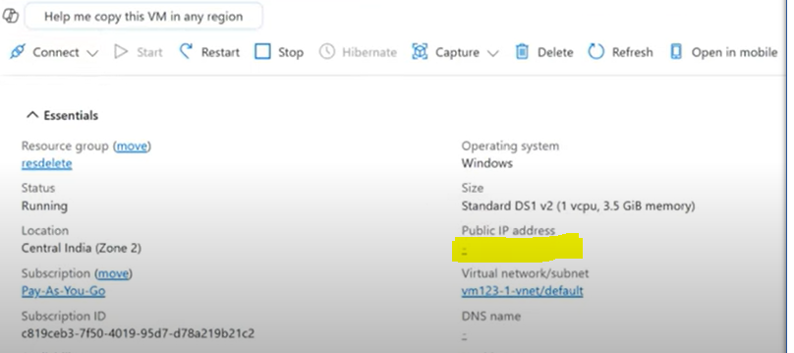
* In the above screenshot, it does not having the public address, bcz we have the manual load balancer by having the redundancy of vm2.
* If our 1st VM1 goes down, then we have to associate the second VM2 for better performance.
  + First step has to dissociate the first vm1. Shown in the figure below.
  + 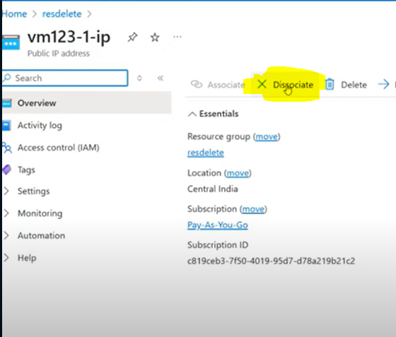 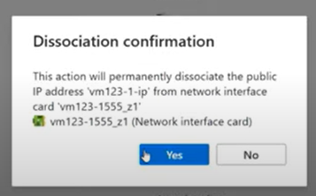
  + Then associate it with the VM2.
  + 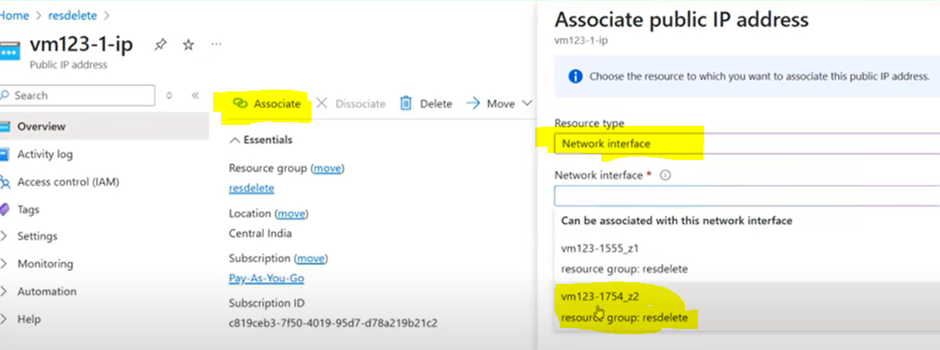
  + In this, we have to choose the resource type as Network interface. (not the Load balancer)
  + Then choose the VM2.
  + 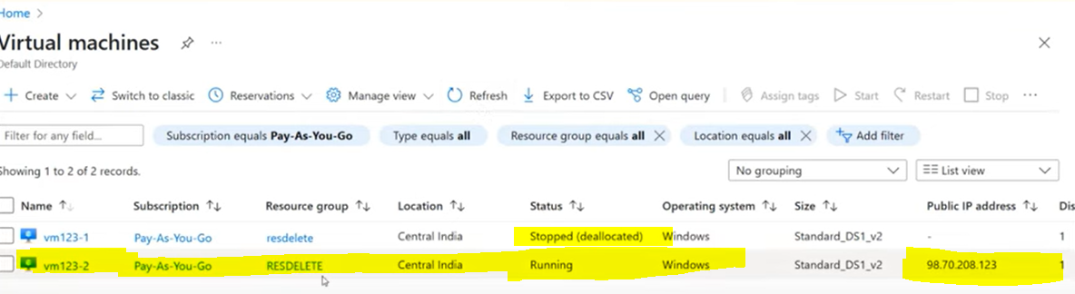
  + Here we can copy our public IP address and connect our Remote VM2.



Let's connect these with the previous dissociate and associate to learn some theoretical Vocabulary:

**Disaster Recovery**

* If there is a disaster, then we need to talk about Disaster Recovery.
* DR 🡪 Disaster Recovery 🡪 it is not automatic.
* It will take days or years to recover.
* 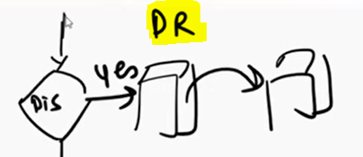

**High Availability**

* How much downtime can you wait?
* Then here they are talking about High Availability.
* We can have some downtime, but it can't exceed that period, whatever is you define.
* Availability Zone is the implementation of the High Availability just we saw before.
* 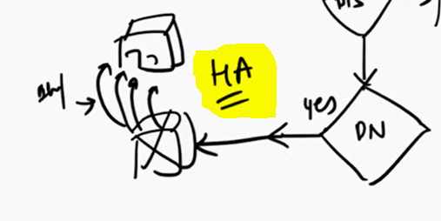

**Fault Tolerance**

* If we don’t have the downtime to wait even an hour, then we are talking about Fault Tolerance.
* Because we need immediate action on what to do next if something happens.
* If something goes wrong, then we will switch the server or a VM, or a system to avoid the problem.
* We cannot have the downtime
* 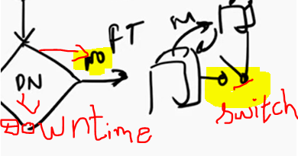

**Scalability**

* If the load increases, your resource back also increases automatically.
* 
* Scalability, taking 1 to 4 servers if there is more traffic.

**Elasticity**

* If there is no traffic and it is below less, then it should choose from 4 servers to 1 server automatically.
* 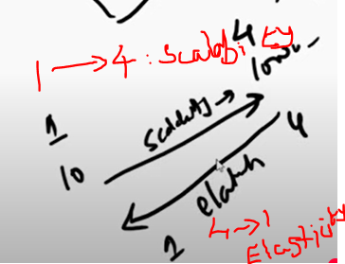



Using the VM, let's have the **demo for Scalability and Elasticity:**

* If the VM goes above 50%, then span the VM
* If the VM goes below 40%, then reduce the VM
* **Virtual Machine Scale Set** 🡪 A group of VMs that can be added automatically if you have more load, and can be decreased automatically if you have less load.
* 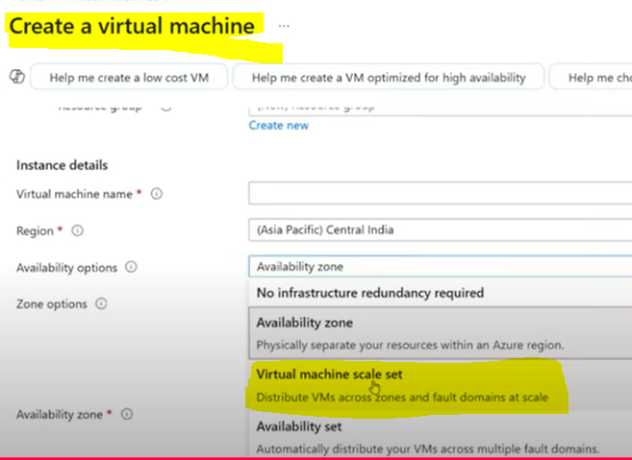
  + **No infrastructure redundancy required** 🡪No redundancy (Like use and throw)
  + **Availability Zone** 🡪 Create two VMs, one as a backup. If anything happens in the 1st, then I will go and take the 2nd VM.
  + **Virtual machine scale set** 🡪 Flexibility and Elasticity.
  + 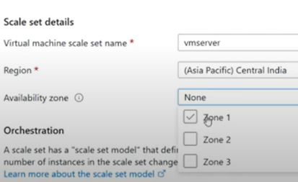
  + 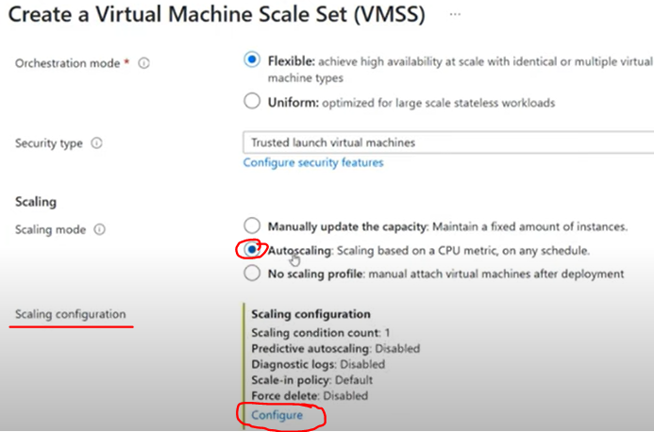
  + 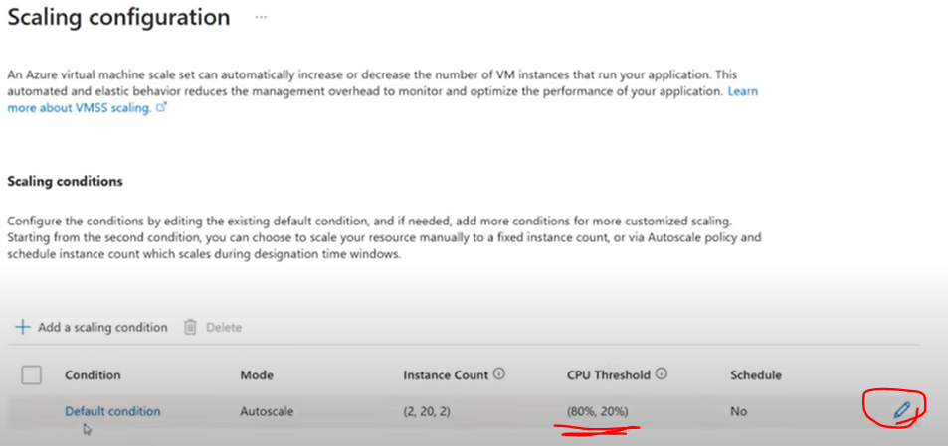
  + 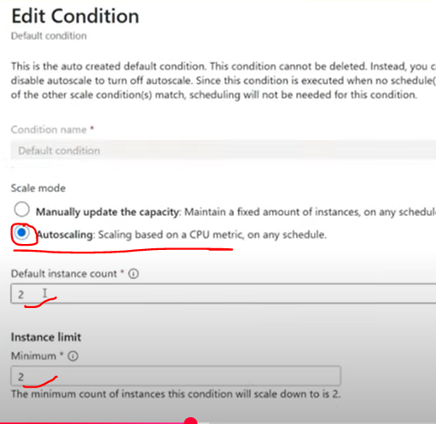
  + 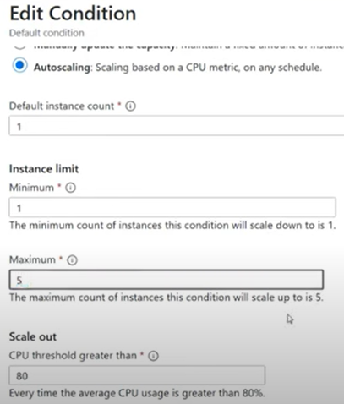
  + 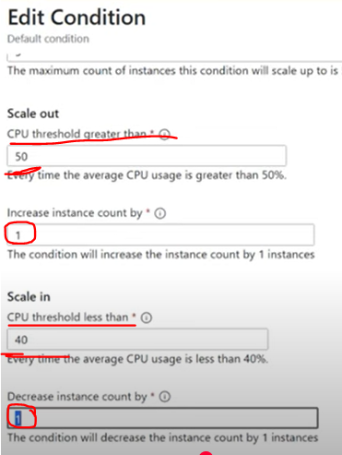
  + 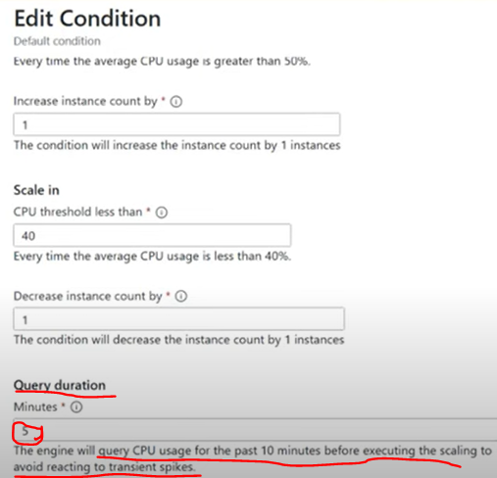
* **Availability set** 🡪

**Network Security Group:**



* A Network Security Group (NSG) in Azure is like a set of rules for your virtual network.
* It controls inbound and outbound traffic to network interfaces, VMs, and subnets.
* **Example:** You can think of it as a bouncer at a club, deciding who gets in and who goes out, based on security rules you set up.
* Imagine your Azure resources are in a building, and the Network Security Group (NSG) is the security guard at the door.
* The NSG has a list of rules, like a guest list, that says who can enter the building and who can leave.
* These rules filter traffic based on IP addresses, ports, and protocols.
* So, it keeps unwanted visitors out and ensures only authorized traffic gets through.
  + In this NSG, by default, the RDP port is blocked.
  + 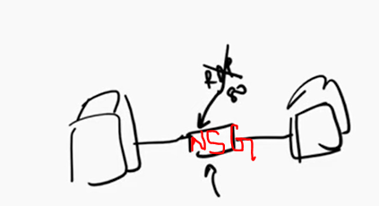
  + So first, we are going to enable the RDP port.
  + Now to the NSG by selecting the Resource group.
  + 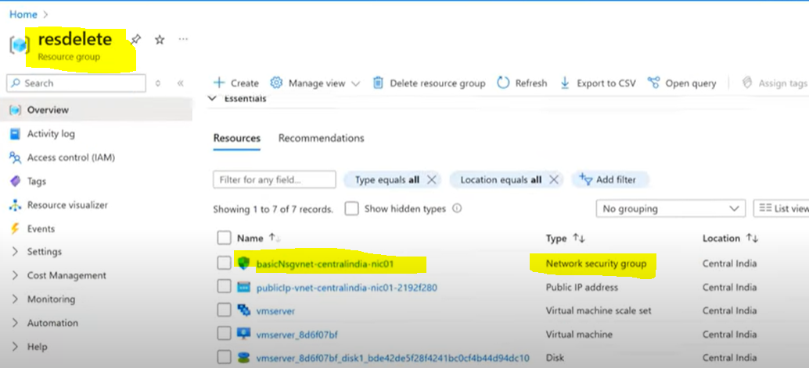
  + 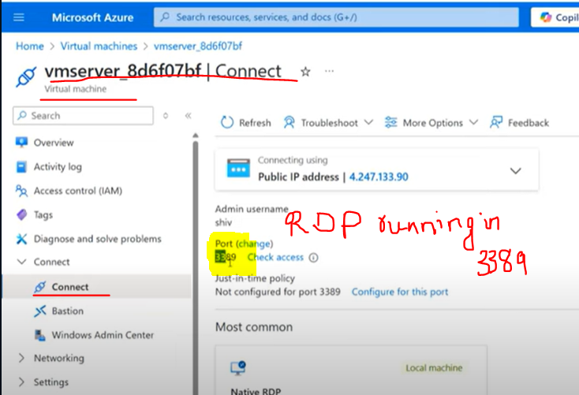
  + 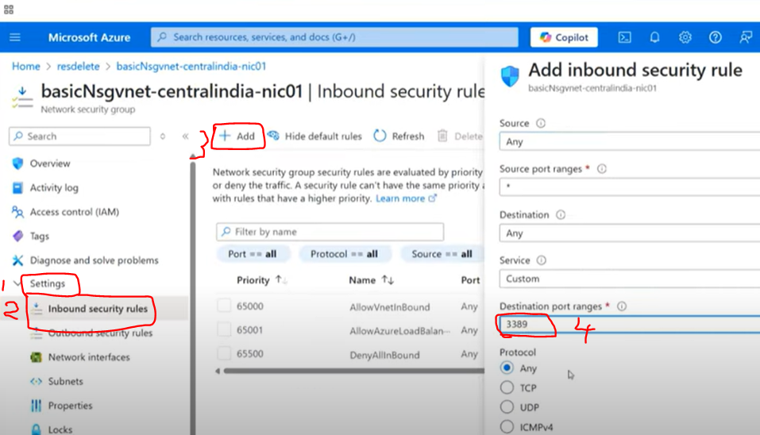
  + 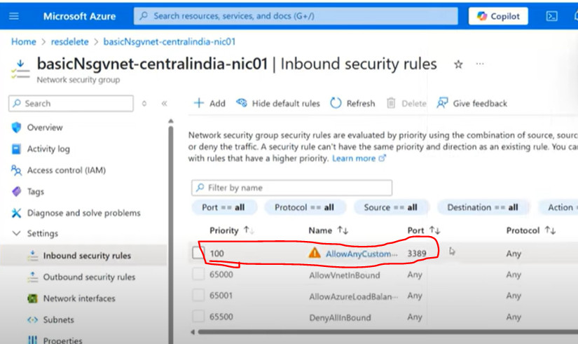
  + Once the RDP 3389 port is added to allow remote access, that particular port will be added in the inbound security rules as shown in the above screenshot.
  + Now, if we try to log in to the Remote machine, we can log in easily.
  + 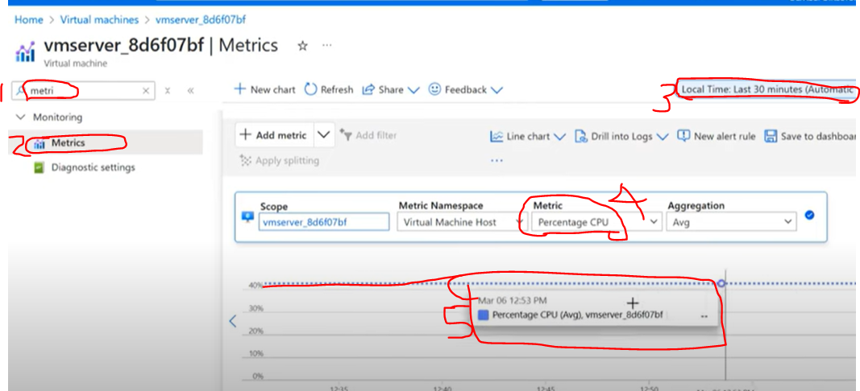
  + To make the CPU percentage more than 40 or 50%, run the **PowerShell**.
  + 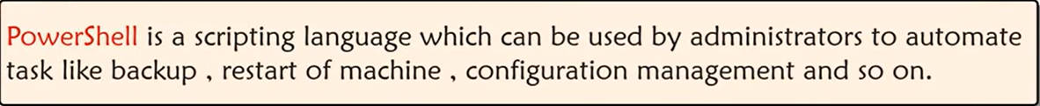
  + Azure PowerShell is a set of tools designed to manage Azure resources directly from the command line, instead of using the Azure portal's graphical interface.
  + You can think of it like a remote control for Azure—it lets you script, automate, and manage Azure tasks efficiently by typing commands.
  + **For instance**, you can create virtual machines, manage storage, or configure network settings, all through PowerShell commands.
  + It’s particularly useful for automating repetitive tasks.
  + Azure PowerShell is like a toolbelt that helps you control and manage Azure by typing commands instead of clicking around.
  + It’s great for automating tasks and getting things done quickly, like creating or managing your Azure resources.
  + 
  + The above PowerShell code will run, and it will make the CPU go above 50%, and once it goes above 50%, what I should see is one to 4, I should see one VM server out here flashed.
  + In the Remote machine, open the PowerShell and paste the while (….) code of the above screenshot.
  + 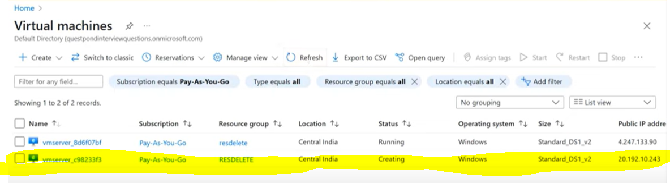
  + The load increased 50%, so it automatically added one more VM by its own.
  + The above action is called **Flexibility.**
  + Now close the remote VM PowerShell and come back to check the metric of CPU percentage.
  + It automatically removes the newly generated VM.
  + 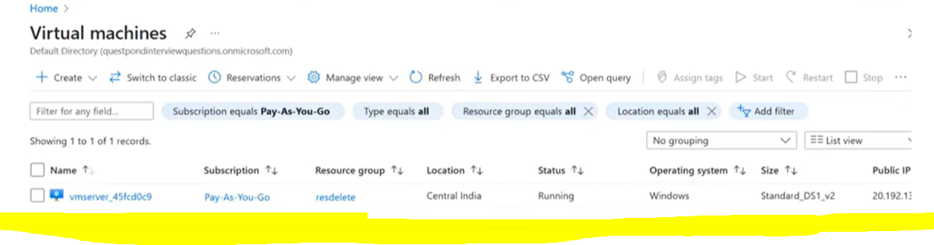
  + The above action is called **Elasticity**



**AZ900 is the Microsoft Azure Fundamentals Exam:**

1. You are tasked with deploying Azure virtual machines for your company. You need to make use of the appropriate cloud deployment solution.

* **Solution:** You should make use of a platform as a service (PAAS).
* **Hint:** IAAS - VM
  + Yes or No
    - * **\*No*.**
      * PaaS is used for building, deploying, and managing applications without focusing on the underlying infrastructure.
      * However, deploying virtual machines in Azure typically falls under **\*Infrastructure as a Service (IaaS)\***
      * because you're dealing with the operating system, networking, and storage, which are aspects of infrastructure.

1. Mark true or false for the statements below.

* Pay-as-you-go is an example of CapEx.
  + **\*False\*** - It's OPEX, as it represents ongoing costs for services or subscriptions.
* Azure VM instances are an example of OpEX.
  + **\*True\*** - Paying for Azure VM instances is an operational expenditure.
* Creating your own data center is an example of CapEx.
  + **\*True\*** - Building a data center is a large upfront investment, aligning with CAPEX.

1. Mark the correct answers:
   1. Azure provides flexibility between capital expenditure and operational expenditure.
      1. Yes, that's correct!
      2. Azure provides flexibility between \***capital expenditure (CapEx)* and *operational expenditure (OpEx)**\*.
      3. This means you can choose to make upfront investments (CapEx) or pay-as-you-go based on usage (OpEx),
      4. Which allows businesses to manage costs effectively depending on their financial strategy.
   2. If you create two Azure virtual machines that use the B2S size, each virtual machine will always generate the same monthly costs.
      1. No, this is not correct.
      2. While the B2S size virtual machines have the same base cost, the \***monthly costs may vary**\*
      3. Depending on factors like additional usage (e.g., disk storage, data transfer), the region where the virtual machines are deployed, and any associated resources like networking or backup services.
      4. These differences in resource usage and settings can lead to variations in costs.
   3. When an Azure virtual machine is stopped, you continue to pay storage costs associated with the virtual machine.
      1. Yes, this is *correct*.
      2. Even when an Azure virtual machine is stopped, the storage associated with the VM, like the virtual hard disk (VHD)—remains, and you continue to incur costs for it.
      3. This is because the data is still preserved, and Azure charges for the storage used.
      4. If you want to stop storage costs, you would need to delete the virtual machine and its associated resources.
         1. **Incur costs:**

* In Azure, to "incur cost" means that you are being charged for using specific Azure resources or services.
* These charges are based on the resources you consume, such as virtual machines, storage, data transfers, or databases.
* Even if some resources are not actively in use, like a stopped virtual machine, costs can still accumulate for associated services like storage.
* It's essentially the process of accumulating charges for the resources and services you use in Azure's pay-as-you-go pricing model.

1. A company is planning on creating several virtual machines in Azure. They would be using the Azure virtual machine service. Which of the following is the right category to which the Azure virtual machine service belongs?
   1. IAAS (Infrastructure as a Service)
   2. PAAS (Platform as a Service)
   3. SAAS (Software as a Service)
   4. FAAS (Function as a Service)
      1. The correct answer is \***A. Infrastructure as a Service (IaaS)**\*.
      2. Azure Virtual Machines belong to the *IaaS* category because they provide control over the underlying hardware and infrastructure,
      3. allowing users to manage aspects like operating systems, storage, and networking.
2. You plan to migrate a web application to Azure, which is accessed by external users. You need to recommend a cloud deployment solution to minimize the administrative effort required to manage the web application.

What should you include in the recommendation?

* 1. SAAS (Software as a Service)
  2. PAAS (Platform as a Service)
  3. IAAS (Infrastructure as a Service)
  4. DAAS (Database as a Service)
     1. **SaaS (Software as a Service)**
        1. This is typically used for pre-built software applications accessible over the internet, like Office 365.
        2. It wouldn't be ideal for hosting your custom web application.
     2. **PaaS (Platform as a Service)**
        1. This is a great choice for minimizing administrative effort because Azure manages the infrastructure, operating system, and runtime environment for your application.
        2. You only need to focus on developing and managing your web app.
     3. **IaaS (Infrastructure as a Service)**
        1. Provides virtualized computing resources over the Internet.
        2. While flexible, it requires more administrative effort as you manage the operating system, middleware, and runtime.
     4. **DaaS (Database as a Service):**
        1. This option specifically focuses on database management and wouldn't cover hosting the entire web application.

**Recommendation:** **Answer is PAAS**

* The ideal solution to minimize administrative effort for managing a web application in Azure is **\*Platform as a Service (PaaS)\***.
* It handles most of the backend complexity, letting you focus on your application.

1. When you are implementing a software as a service (SAAS) solution, you are responsible for **CONFIGURING HIGH AVAILABILITY**.

Review the above underlined text.

If it makes the statement correct, select “No change is needed”.

If the statement is incorrect, select the answer choice that makes the statement correct.

* 1. No Change is needed
  2. Defining scalability rules
  3. Installing the SAAS solution
  4. Configuring the SAAS solution
     1. In a SaaS model, the service provider typically handles high availability, scalability, and infrastructure management.
     2. As the consumer, your responsibilities are primarily limited to \***configuring the SaaS solution**\* to align with your specific business needs (e.g., user roles, application preferences).

**Correct Answer:**

* + - 1. "You are responsible for configuring high availability." This is **\*incorrect\***
      2. Because configuring high availability is generally managed by the SaaS provider.
      3. **The best answer to correct the statement would be *D. configuring the SaaS solution\***, as it reflects your actual role in using the service.

1. You have an offline network with several servers. You are migrating the same to Azure.

You need to recommend a solution to ensure that some of the servers are available even if a single Azure datacenter goes offline for an extended period.

What should you include in the recommendation?

* 1. Fault tolerance
  2. Elasticity
  3. Scalability
  4. Low latency
     1. A. **Fault Tolerance:**
        1. This is the ability of a system to continue functioning even when part of it fails.
        2. It's a key requirement for achieving high availability, especially in scenarios where datacenters might go offline.
     2. B. **Elasticity:**
        1. This relates to dynamically scaling resources based on demand but isn't directly tied to maintaining availability during a datacenters outage.
     3. C. **Scalability:**
        1. While scalability ensures, a system can handle increasing workloads, it doesn't inherently guarantee availability during failures.
     4. D. **Low Latency:**
        1. This is about minimizing delays in data transfer and doesn't address the challenge of maintaining availability during outages.

**Recommendation: Answer is A**

* The correct answer is **\*A. Fault Tolerance\***,
* as it directly addresses the need for high availability and resilience in the event of a datacenters failure.

1. Your company hosts an inventory application that is used by all the customers of the company.

This inventory application has low usage during the first three weeks of each month and very high usage during the last week of each month.

Which benefit of Azure cloud services supports cost management for this type of usage pattern?

* 1. High availability
  2. High latency
  3. Elasticity
  4. Load balancing
  5. Scalability
     1. **High availability:**
        1. This ensures the system is always accessible, but doesn't address cost management.
     2. **High latency:**
        1. This refers to delays in data transmission and isn't a benefit for managing costs.
     3. **Elasticity:**
        1. This is the ability to scale resources up or down dynamically based on demand.
        2. For this usage pattern, elasticity allows resources to increase during high usage and decrease during low usage, optimizing costs.
     4. **Load balancing:**
        1. This distributes network traffic across multiple servers for reliability and performance,
        2. But it doesn't directly influence cost management.
     5. **Scalability:**
        1. While this ensures, a system can handle increased workload,
        2. It doesn't inherently optimize costs during fluctuating demand.

**Correct Answer:**

* The most appropriate choice is **\*c. Elasticity*,**
* as it directly supports cost efficiency by adjusting resources based on the application's varying usage patterns.